# KABIRIZI SEC SCHOOL

BEGINNING OF TERM TWO- 2024

S.1 AGRICULTURE

2 hours

INSTRUCTIONS

* This paper consists of three examination items.
* Answer two examination items in all.

Item 1

Agriculture plays a crucial role in society contributing to various values of extends just beyond food production. It is no longer limited to traditional farming but diversified into a wide range of careers that cater for demand of a growing global population and need for sustainable practices.

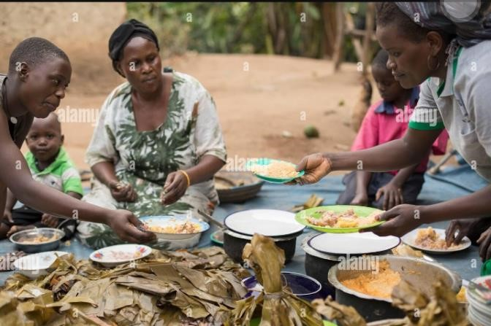

Task

1. As a student who has studied Agriculture, how can u collectively sensitize the vital importance of Agriculture? (10scores)
2. As a diversified student in Agriculture sector, which careers can offer exciting prospects for those who wish to take a meaningful impact in Agriculture (10scores)

**Item2**

In Uganda, agriculture has been approached through various methods, including modern and local/traditional systems. Surprisingly, many farmers continue to rely on traditional/ local farming techniques. This outdated approach has impeded progress of and the income of the farmers.

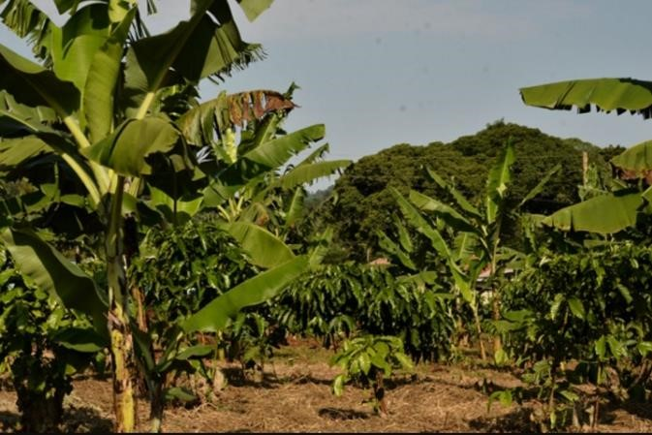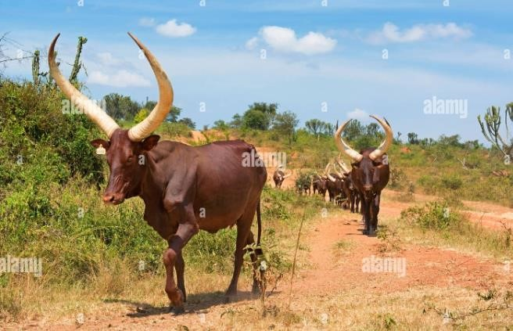

Task

1. As Agriculture specialist, describe the local farming systems that are practiced by

Ugandan farmers. (10scores)

1. Prepare a message to sensitize farmers on how they can improve on these systems.

Item 3

You are a manager of a medium sized dairy farm that produces milk, cheese and yoghurt. The farm has been experiencing fluctuations in milk production over the past few months, and you suspect it might be due to various factors such as changes in feed quality, environmental conditions or animal health issues. Additionally, there has been a noticeable increase expenses related to veterinary care and feed purchase. Your task is to analyze the farm records and identify potential causes for the fluctuations in milk production and increased expenses.

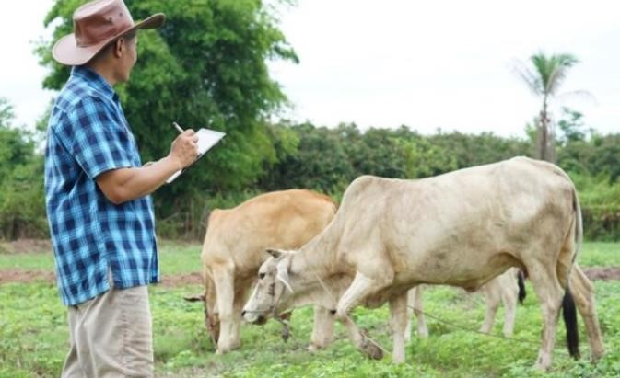

Task

* 1. As a farm manager, Make a write up for the specific records you would keep on the farm to improve production.
  2. Of what importance is record keeping to a farm manager.

*******Farmers are honored and dignified*********